משווה שמיט 741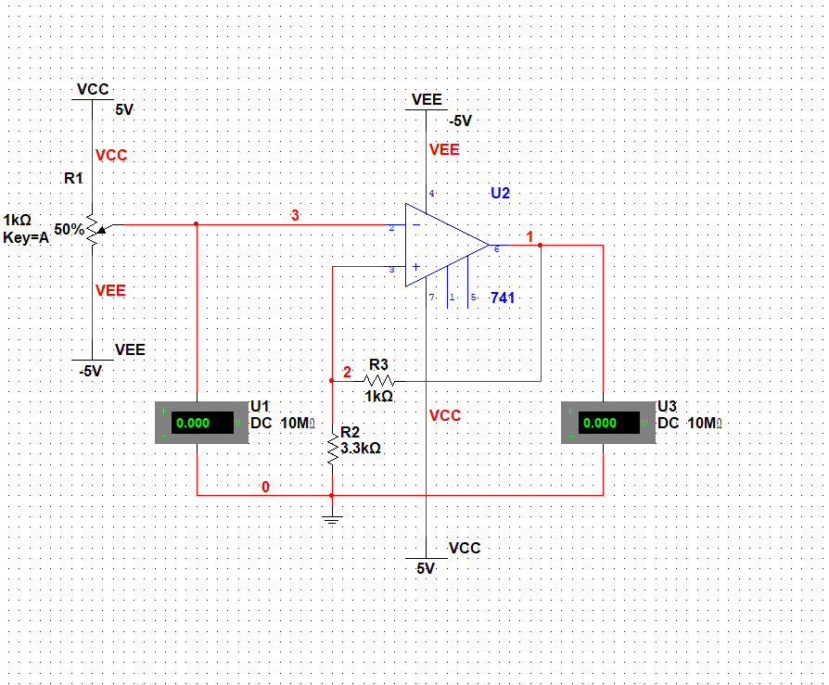

|  |  |  |  |  |  |  |  |  |  |  |  |
| --- | --- | --- | --- | --- | --- | --- | --- | --- | --- | --- | --- |
| Vin(V) | -5 | -4 | -3 | -2 | -1 | 0 | 1 | 2 | 3 | 4 | 5 |
| Vo(V) | 4.117 | 4.117 | 4.117 | 4.117 | 4.117 | 0 | -4.117 | -4.117 | -4.117 | -4.117 | -4.117 |

|  |  |  |  |  |  |  |  |  |  |  |  |
| --- | --- | --- | --- | --- | --- | --- | --- | --- | --- | --- | --- |
| Vin(V) | 5 | 4 | 3 | 2 | 1 | 0 | -1 | -2 | -3 | -4 | -5 |
| Vo(V) | -4.117 | -4.117 | -4.117 | -4.117 | -4.117 | 0 | 4.117 | 4.117 | 4.117 | 4.117 | 4.117 |

מתחי רוויה : 11.115- וולט עד 11.115

מתחי סף : 4.99- וולט עד 4.99